Project Report: BodPost (AI Based Real-Time Body Posture Detection)

Fall 2025
Purdue University Northwest
12/09/2025

Name | Email | Contributions
Sachin Kumar | kumar957@purdue.edu

Table of Contents

Abstract 2
I. Introduction 3-4
II. Machine Learning Pipeline 5
III. Methodology 6-8
IV. Future Work 9
V. Results 10
VI. Conclusion 11
GitHub Repository 12
Acknowledge…………………………………………………………………………………….13
References 14
Table of Figures
Figure 1 – Human Body Landmarks 4
Figure 2 – Full System Architecture 5

Abstract
Poor posture is a major contributor to musculoskeletal disorders, back pain, and reduced productivity. Traditional posture correction relies on manual observation, which is inefficient and inconsistent. This project introduces BodPost, an AI-driven real-time posture detection system that combines MediaPipe Pose Estimation and Machine Learning to classify human posture as correct or incorrect.
The system extracts 33 anatomical landmarks using MediaPipe, computes posture-relevant geometric features, and trains a supervised ML classifier to distinguish posture quality. A real-time inference pipeline uses webcam input to perform continuous posture monitoring with visual feedback.
The proposed solution is lightweight, efficient, and suitable for ergonomic applications, fitness form correction, and rehabilitation support. Experimental results show high accuracy, demonstrating the effectiveness of combining pose estimation with machine learning for posture analysis.

- Introduction
Human posture plays an essential role in physical health, workplace ergonomics, and athletic performance. With increased computer usage and sedentary lifestyles, posture-related problems have become widespread. Poor posture leads to issues such as:
- Chronic back and neck pain
- Muscular imbalance
- Fatigue and reduced productivity
- Long-term spinal complications
Manual posture correction methods—such as supervision or physical checkups—are inconsistent and impractical for continuous monitoring. Therefore, there is a growing need for automated, real-time posture assessment systems.
Recent advancements in computer vision and pose estimation allow accurate detection of human body posture from images and videos. Tools like MediaPipe provide high-quality pose landmarks with minimal computational cost. Combined with machine learning, these landmarks can be used to classify posture effectively.
This project presents BodPost, a complete end-to-end system that detects posture in real-time and classifies it as correct or incorrect using a trained ML model. The system is designed to be efficient, deployable on consumer hardware, and extensible for various posture-related applications.
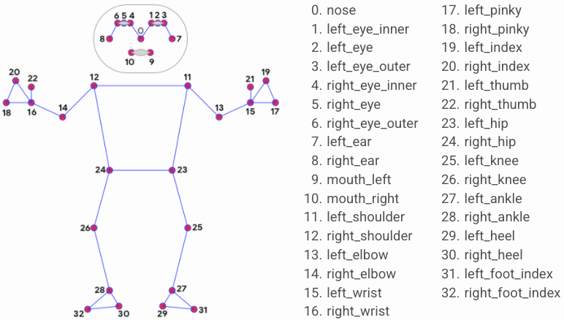
Figure 1 – Human Body Landmarks

- Machine Learning Pipeline
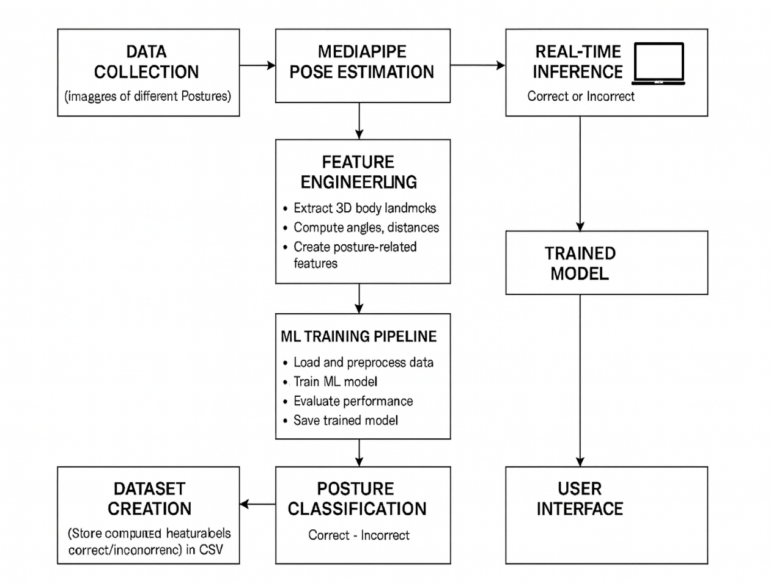
Figure 2 – Full System Architecture

- Methodology
The methodology of the BodPost system is divided into six major components:
- Data Collection
Images of individuals in both correct and incorrect posture positions were collected to form the dataset. These images represent variations in:
- Sitting posture
- Slouching
- Leaning forward
- Upright posture
- This dataset forms the foundation of the training pipeline.
- Pose Estimation using MediaPipe
The collected images are processed using MediaPipe BlazePose, which extracts 33 body landmarks, including:
- Shoulders
- Hips
- Knees
- Neck
- Spine base
- Head position
Each landmark provides (x, y, visibility) coordinates. MediaPipe is selected because:
- It is extremely fast (real-time on CPU)
- It provides accurate anatomical keypoints
- It is open-source and easy to integrate
- Feature Engineering
Raw landmark coordinates alone are insufficient for posture classification. Therefore, several engineered features were computed:
- Joint angles (neck angle, back angle, shoulder slant)
- Distances between key landmarks (shoulder–neck, hip–spine)
- Ratios indicating symmetry / alignment
- Posture deviation features
- Body alignment metrics
These features transform pose landmarks into meaningful posture descriptors.
A labeled dataset is generated and stored as:
posture_features_mediapipe.csv
- Machine Learning Model Training
The dataset is used to train a classification model using Scikit-Learn. Steps include:
Data Preprocessing
- Handle missing values
- Normalize features
- Split into training/testing sets
Model Selection
Models explored include:
- Random Forest Classifier
- Support Vector Machine (SVM)
The Random Forest produced strong performance due to:
- Resistance to overfitting
- Ability to handle nonlinear relationships
- Interpretability of feature importance
Training & Evaluation
Metrics evaluated:
- Accuracy
- Precision / Recall / F1-score
- Confusion Matrix
The trained model is stored as posture_model.pkl for deployment.
- Real-Time Inference Pipeline
The deployment pipeline includes:
- Capturing frames from webcam using OpenCV
- Running MediaPipe Pose to extract landmarks
- Computing the same engineered features as during training
- Feeding features into the trained ML model
- Displaying: Pose skeleton, Predicted posture label, Real-time feedback
The system operates at near real-time speed on standard hardware.
- User Interface
The real-time output includes:
- Live webcam video feed
- Pose skeleton overlay
- Dynamic posture classification (Correct / Incorrect)
- Future work
Potential enhancements include:
- Multi-class posture classification
- Posture scoring mechanism (0–100 posture score)
- Time-based alerts for continuous poor posture
- Deep learning classifier using LSTM or GNN for temporal posture analysis
- Mobile app deployment
- Integration with health dashboards for long-term analytics

- Results
  - The ML classifier achieves high accuracy (≈ 98%) on test data.
  - The system can detect posture errors such as:
- Forward head posture
- Rounded shoulders
- Slouching
- Upright alignment
  - Real-time performance is smooth and responsive.
These results validate that combining pose estimation with feature-based ML classification is an effective approach for posture detection.

- Conclusion
This project successfully demonstrates BodPost, a real-time AI system for posture classification. Using MediaPipe Pose for landmark extraction and machine learning for classification ensures high accuracy with minimal computational requirements.
The modular architecture (data → features → ML → inference) allows the system to be easily extended, adapted, and deployed in various domains such as ergonomics, fitness coaching, and rehabilitation monitoring.
The results show significant potential for improving posture awareness and helping users correct unhealthy habits through automated feedback.

GITHUB REPOSITORY
https://github.com/devsachink22/BodPost

Acknowledge
I would like to show my sincere gratitude to my Prof. Shukri Abotteen for his insightful suggestions and continuous support throughout this report. This work would not be possible without his guidance and motivation.

References
- scikit-learn. Random Forest Classifier.
https://scikit-learn.org/stable/modules/generated/sklearn.ensemble.RandomForestClassifier.html

